**The First Computer Bug!**



Date: 23 Aug 1981 05:38:25-PDT

From: ARPAVAX.sjk at Berkeley

Subject: origin of bug

Ever wondered about the origins of the term "bugs" as applied to computer

technology? U.S. Navy Capt. [Grace Murray Hopper](http://www.cs.yale.edu/HTML/YALE/CS/HyPlans/tap/Files/hopper-story.html) has firsthand explanation.

The 74-year-old captain, who is still on active duty, was a pioneer in

computer technology during World War II. At the C.W. Post Center of

Long Island University, Hopper told a group of Long Island public school

administrators that the first computer "bug" was a real bug -- a moth.

At Harvard one August night in 1945, [Hopper](http://www.cs.yale.edu/HTML/YALE/CS/HyPlans/tap/Files/hopper-story.html) and her associates were working

on the "granddaddy" of modern computers, the Mark I. "Things were going

badly; there was something wrong in one of the circuits of the long

glass-enclosed computer," she said. "Finally, someone located the

trouble spot and, using ordinary tweezers, removed the problem, a two-inch

moth. From then on, when anything went wrong with a computer, we said it

had bugs in it." [Hopper](http://www.cs.yale.edu/HTML/YALE/CS/HyPlans/tap/Files/hopper-story.html) said that when the veracity of her story was

questioned recently, "I referred them to my 1945 log book, now in the

collection of Naval Surface Weapons Center, and they found the remains of

that moth taped to the page in question."

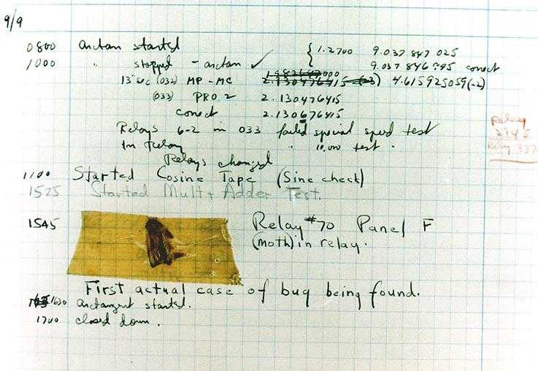

The first computer bug, courtesy of the [History of Computing](http://ei.cs.vt.edu/~history/) page at [Virginia Tech](http://ei.cs.vt.edu/).

Last update: 2001-06-11 by [<dennette@wiz-worx.com>](mailto:dennette@wiz-worx.com?subject=Adm.%20Hopper)

